VEXTRACTOR V3.94
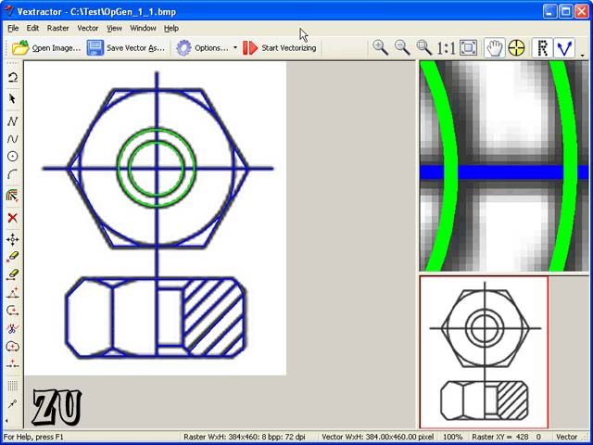
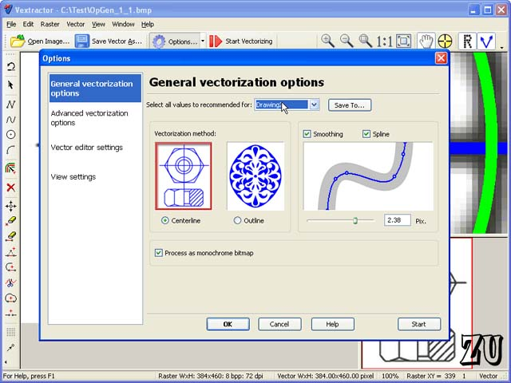
SIZE: 5.05 MB
Vextractor is a professional software for converting raster images to vector (vectorizer). Vextractor converts drawings, maps and other images, including photo, logos, black-and-white illustrations from raster to vector format. The program can save converted raster images to the following vector formats: DXF, WMF, EMF, EPS, AI or SVG. Files of these vector formats can be imported to popular vector graphics applications like AutoCAD, Corel Draw, Adobe Illustrator, and many others. For the purpose of supporting GIS applications, the program allows saving images to the ArcInfo Shape and MapInfo MID/MIF formats. This software is a perfect replacement for the traditional tracing and digitizing. It can save lots of your time, for it is much quicker to use this program rather than do the tracing by hand or using a digitizer.
Why Do You Need Vextractor?
Chances are these days you can open raster files (e.g., BMP, TIFF, PNG, JPG) with your favorite CAD program - the majority of modern CAD programs can import and display raster images. However, as soon as you import your raster file in your CAD program, you will find out that all you can do with it is just view it and trace it over. You are unable to modify or edit the raster as easily as you can do vector data. That takes place because CAD software can only work with vector files. If you want to edit raster files in a CAD application you are to convert them to vector files first. That can be done with a raster to vector conversion program (vectorizer). Once your raster image is converted to the vector format, you will be able to import it in your CAD application and then edit it like any other drawings that you do with your CAD application.
The list below summarizes the conversion of hard-copy drawings to CAD drawings, using the raster to vector converter:
1. Create a raster file by scanning a hard-copy drawing with a scanner.
2. Use Vextractor to convert the raster file to the vector format.
3. Import the vector file to your CAD application.
4. Edit the drawing in your CAD application.
Vextractor can replace the traditional tracing and digitizing applications. It offers a simple and easy way to convert paper-based drawings to CAD drawings for further editing and use. Vextractor will save many hours of your time and free you from the boring and monotonous work.
Vextractor Usage Examples:
1. Suppose you have an archive of a great number of raster drawings, pictures or logos, which you can only view and print. The possibility to convert that data to the vector format would be very helpful for your work.
2. Desktop small-format (A4) scanners are very popular today. Multitudes of CAD professionals have the need for scanning drawings and then converting them for editing in CAD applications. Now you can convert hand-made machine-building, electro-technical or architecture drawings to your CAD application and save them to disk.
3. If you have a hardcopy or raster image (photo), and you want to engrave a 3D inscription, logo or image on the metal, wood or plastic. Now you can convert the raster file to the input format (usually, dxf) for a CNC cutting or router system.

